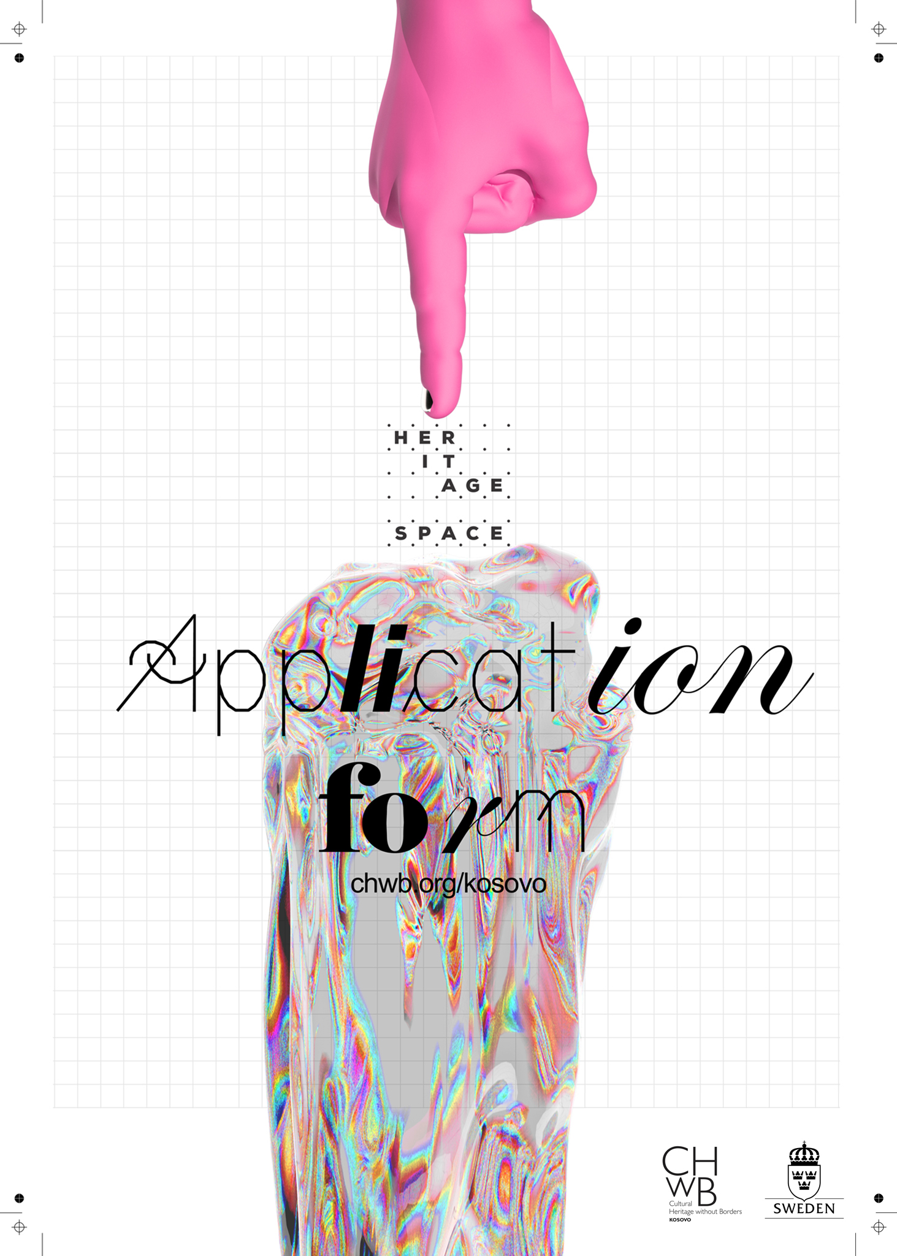

**Application Form 2020**

Applications for Heritage Space platform are open to:

* All residents of Kosovo over the age of 21 regardless of gender, ethnicity and/or background.
* Individuals whose ideas are based on new opportunities offered by creative industries and cultural heritage.
* Those with elementary knowledge of both cultural heritage and the creative field.
* Visual artists, designers, filmmakers, writers, researchers, performers, curators, historians, anthropologists, photographers, craftsmen and anyone whose creative activity fits with the application criteria.
* A maximum of two individuals can apply with one project idea.

*\*It is recommended you invest some time before submitting your application. Do not limit your ideas only to tangible culture (buildings or objects). Cultural heritage encompasses a much broader area of social life.*

*\*Career status is not a priority, since ideas can be phenomenal irrespective of work experience or academic background;*  
  
***Fields marked with ( * ) are required.***

**Information**

* This form contains your personal data and eight (8) questions including the Action Plan and Budget Line.
* Applications are accepted in Albanian, Serbian and English.
* Neither non-individual entities nor organizations/companies/NGOs are eligible for applying.

Before you fill out this form, CHwB Kosovo strongly encourages you to read the following link:

[**Application Guideline**](http://chwb.org/kosovo/wp-content/uploads/2020/08/Application-Guideline-Heritage-Space-2020-2.pdf)**.**

**HOW ARE YOU APPLYING? \***

As an individual

As a group of two (2) individuals

|  |  |
| --- | --- |
| **Name and Surname\*** |  |
| **Profession\*** |  |
| **Birthday* (DD/MM/YY)** |  |
| **Gender\*** | W  M  Other ________ |
| **Residence\*** |  |
| **Address\*** |  |
| **E-Mail\*** |  |
| **Phone Number\*** |  |

**1. Project information (300 words max). \***

(Describe your project generally. Pay specific attention to the innovative and creative aspects of your idea. If desired, add a photo / video in order to illustrate the idea and attach them together with the application form.)

|  |
| --- |
|  |

**1.1 Project Summary. \***

|  |  |
| --- | --- |
| **Project name** |  |
| **Project location (specify the region or city where the project will be implemented)** |  |
| **Which cultural disciplines or mediums will be covered by the project (research, video, documentary, publication, crafts, handicraft, music, application, VR, design etc.)** |  |
| **Duration of the project** |  |
| **The total amount required from Heritage Space (sum in euros)** |  |

**2. How does your project contribute to the preservation, visibility or revival of Cultural Heritage (max 300 words). \***

(Explain how your cultural practice (field/discipline/medium), part of the proposed project-idea, will intersect with certain content of cultural heritage and explain how your perspective and approach brings novelty in relation to cultural heritage)

|  |
| --- |
|  |

**3. Activities and Results (max 300 words). \***

(Provide information on the project's stages of development, activities and expected results. Ensure that these activities are achievable within the proposed budget and timeframe)

|  |
| --- |
|  |

**3.1 Specify if there are other individuals involved in the project?**

(Name, occupation and their role in your project)

|  |
| --- |
|  |

**4. Is your project sustainable? \***

(Please provide information on the sustainability of the project beyond Heritage Space time-frame. Is your project part of a larger project or personal plan and how you will ensure that your project continues successfully beyond the scope of the Heritage Space platform?)

|  |
| --- |
|  |

**5. How will your project be accessible for the general public?**

(Please provide information about the accessibility of your final work. How do you plan to disseminate your work publicly, and how will you make sure that people will have access to the final material/work at all times)

|  |
| --- |
|  |

**6. Does your project have any impact on women, ethnic groups, independent or low income artists, or any other marginalized group? If yes, please explain how. (max 200 words)**

|  |
| --- |
|  |

**7. Action Plan \***

|  |  |  |  |  |  |  |
| --- | --- | --- | --- | --- | --- | --- |
| **Activity** *(List the activity here and mark with [X] the implementation period on the right side of the table)* | **Month** | | | | | |
| **Oct** | **Nov** | **Dec** | **Jan** | **Feb** | **Mar** |
|  |  |  |  |  |  |  |
|  |  |  |  |  |  |  |
|  |  |  |  |  |  |  |
|  |  |  |  |  |  |  |
|  |  |  |  |  |  |  |

**8. Budget \***

|  |  |  |  |  |
| --- | --- | --- | --- | --- |
| **Expense Category** | **Unit**  *(days, months, kg, lt etc)* | **Number of Units** | **Cost** | **Total** |
| Human Resources (below list the roles of people involved) |  |  |  |  |
|  |  |  |  |  |
|  |  |  |  |  |
|  |  |  |  |  |
| Activities and Logistics (events, transport, travel etc) |  |  |  |  |
|  |  |  |  |  |
|  |  |  |  |  |
|  |  |  |  |  |
| Materials |  |  |  |  |
|  |  |  |  |  |
|  |  |  |  |  |
|  |  |  |  |  |
| **TOTAL:** | | | | |

**The applications for consideration consist of these parts:**

For an application to be taken into consideration the following is required:

* Complete the application form;
* Send your CV (portfolio if available);
* Your personal ID (scanned)
* Applications can contain any other additional document related to the project such as videos/audios, sketch, publications, or other document that may be useful for the selection process, as long as they are shared via an online link.

Please complete this form in full by computer. The application form, together with other

required documents should be submitted no later than: September 05 (time 23:59), via email: [chwb.kosovo@gmail.com](mailto:chwb.kosovo@gmail.com). When submitting the application via email, please write in the subject line: “Application for Heritage Space 2020 (Name Surname)”.